ASSESSMENT 6

*“SQL PROCEDURES & DATABASE SCHEMAs”*



Submitted By

VAIBHAV PATIDAR

IPS ACADEMY, INDORE (M.P.)

**Date :** 09-12-2023

**Week 1** | **Day - 06**

**SOME & ALL OPERATOR :**

* The SOME operator willr return the results which follows SOME conditions in query.
* ALL operator will return the results which follow each and every condition in query.

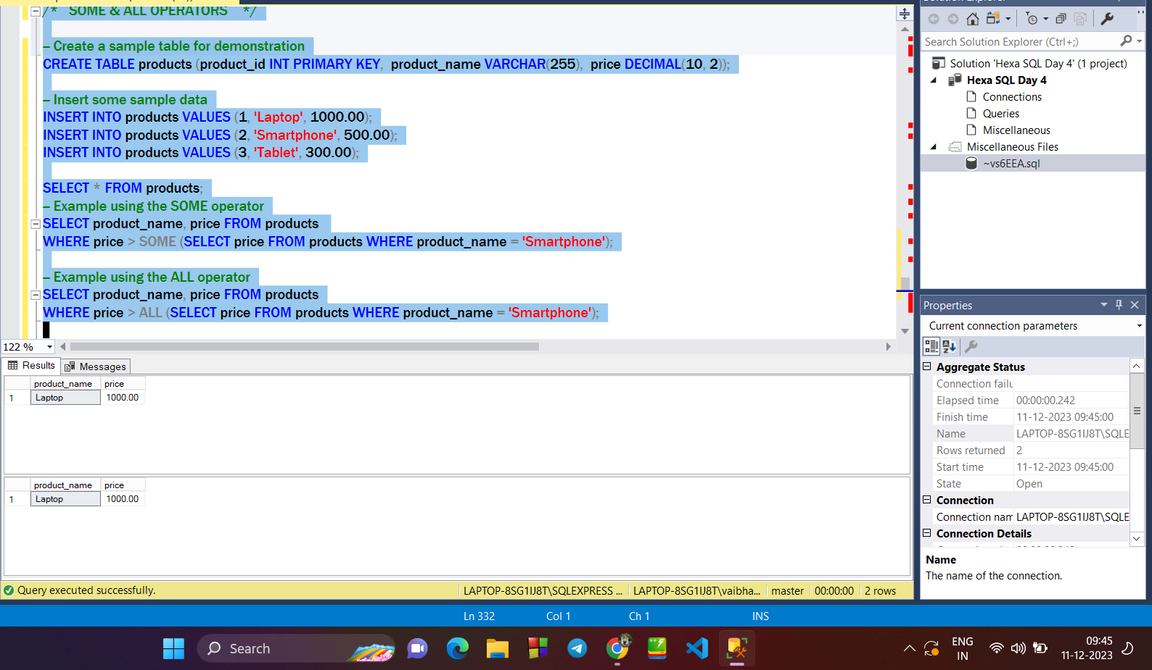

**WITH Clause in SQL :**

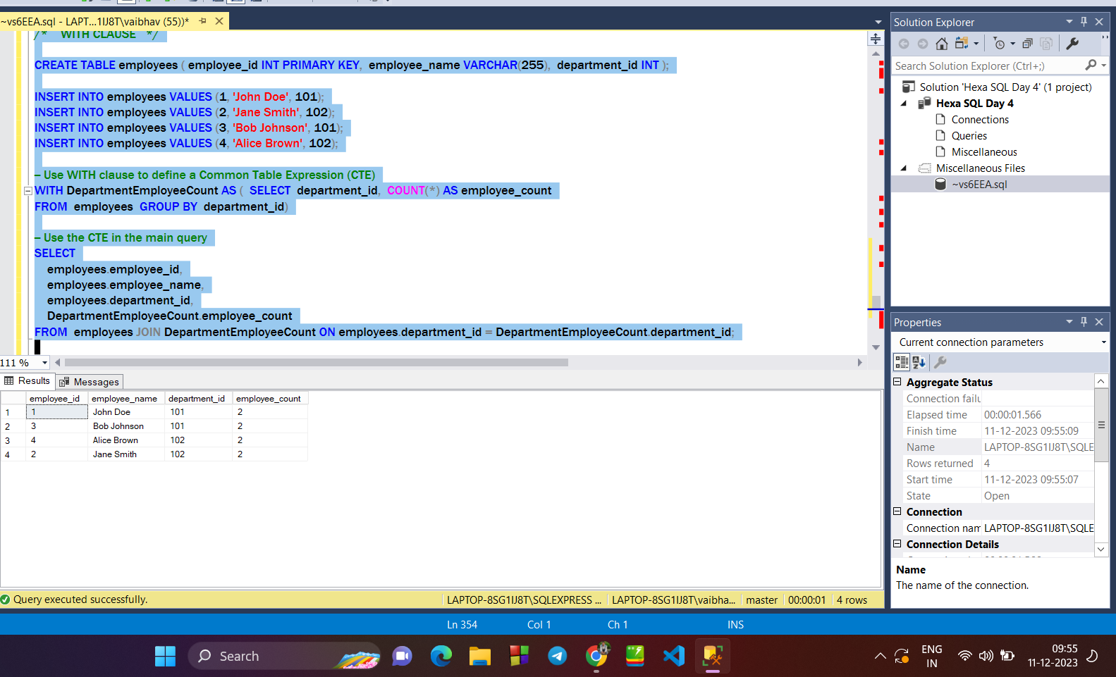

**STORED PROCEDURE :**

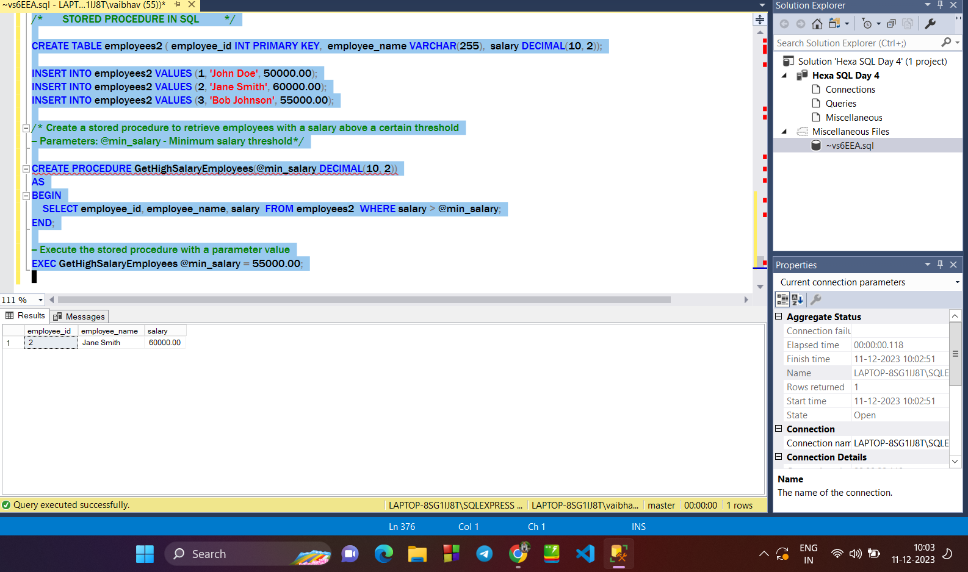

**ROLLUP Command in sql :**

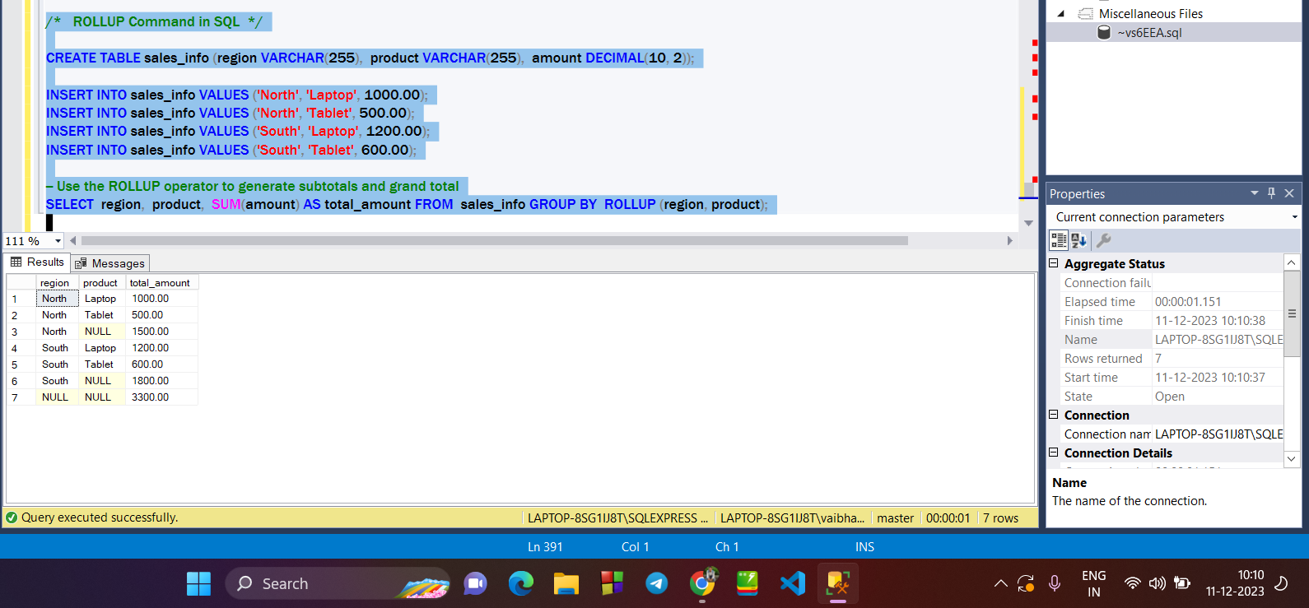

**STAR & SNOW-FLAKE Schema in SQL :**

The **STAR and SNOWFLAKE schemas** are two common approaches to designing a data warehouse schema in SQL.

**STAR Schema :**

**Structure:**

* Consists of one or more fact tables and associated dimension tables.
* The fact table typically contains numerical measures (e.g., sales amount), and dimension tables store descriptive information related to the measures.

**Relationships:**

* Fact tables are at the center, surrounded by dimension tables.
* Each dimension table is directly related to the fact table, forming a star-like shape.

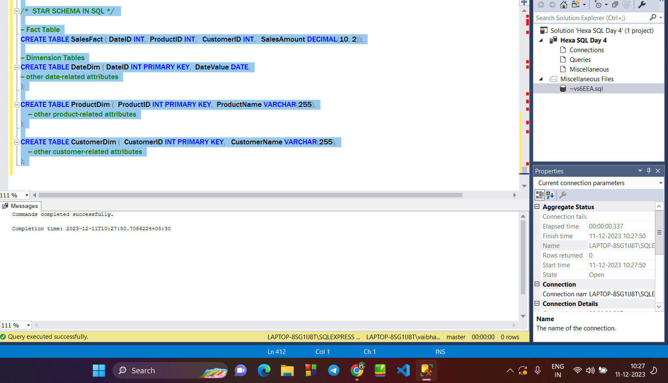

**SNOWFLAKE Schema :**

**Structure:**

* Similar to the STAR schema but with additional normalization.
* Dimension tables in a SNOWFLAKE schema are normalized, meaning they may be further divided into sub-dimensions.

**Relationships:**

* Dimension tables are connected in a chain-like structure, resembling a snowflake.

